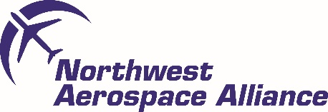

NWAA AGM & Winter Member Forum 2021 Delegate Booking Form
Company Name
Delegate Name
Delegate Job Title
Contact Number
Email Address
Postal Address

Social Media details | Twitter:  LinkedIn:

** Please indicate if you are coming to the AGM (this is for members only)
and / or Winter Member Forum **
 | Price * | Number of tickets Required
NWAA Member Ticket AGM (AGM is for members only) | FREE OF  CHARGE
NWAA Winter Forum  (Member) | £40:00
NWAA Winter Forum  (Non-Member) | £85:00
*Please note price excludes VAT.
Signed
Date
Purchase Order Number

Please email back to Claire.lambert@aerospace.co.uk

Registered address: North West Aerospace Alliance – Nelson Office. Pendle Business Centre, Commercial Road, Nelson, Lancashire. BB9 9BT
http://www.aerospace.co.uk/
Company Registration Number: 3005520
VAT Registration Number : 634 0252 74

